Bahria University,

Karachi Campus



COURSE: CSC-110 COMPUTING FUNDAMENTALS

TERM: FALL 2020, CLASS: BSE- 1 (B)

Submitted By:

M MUAZ SHAHZAD__________02-131202-081

(Name) (Reg. No.)

Submitted To:

Dr. Salahuddin / Engr. Saniya Sarim

Signed Remarks: Score:

INDEX

|  |  |  |  |  |
| --- | --- | --- | --- | --- |
| SNO | DATE | LAB  NO | LAB OBJECTIVE | SIGN |
| 01 | 1-OCT | 03 | Introduction to Microsoft Visio |  |
|  |  |  |  |  |
|  |  |  |  |  |
|  |  |  |  |  |
|  |  |  |  |  |
|  |  |  |  |  |
|  |  |  |  |  |
|  |  |  |  |  |
|  |  |  |  |  |
|  |  |  |  |  |
|  |  |  |  |  |
|  |  |  |  |  |
|  |  |  |  |  |
|  |  |  |  |  |
| SNO | DATE | LAB NO | LAB OBJECTIVE | SIGN |
|  |  |  |  |  |
|  |  |  |  |  |
|  |  |  |  |  |
|  |  |  |  |  |
|  |  |  |  |  |
|  |  |  |  |  |
|  |  |  |  |  |
|  |  |  |  |  |
|  |  |  |  |  |
|  |  |  |  |  |
|  |  |  |  |  |
|  |  |  |  |  |
|  |  |  |  |  |
|  |  |  |  |  |
|  |  |  |  |  |

Bahria University,

Karachi Campus



LAB EXPERIMENT NO.

**3**

LIST OF TASKS

|  |  |
| --- | --- |
| TASK NO | OBJECTIVE |
|  | Draw flowcharts for the following scenarios: |
| 1 | Ordering a book. |
| 2 | Taking Admission in university. |
| 3 | Fee payment procedure in a university. |
| 4 | Reporting a crime in police station. |
| 5 | Hiring a cab. |
|  |  |
|  |  |
|  |  |
|  |  |
|  |  |
|  |  |
|  |  |
|  |  |
|  |  |
|  |  |

Submitted On:

Date: 15/10/2020

**Task No. 1: Ordering a book**

**Solution:**

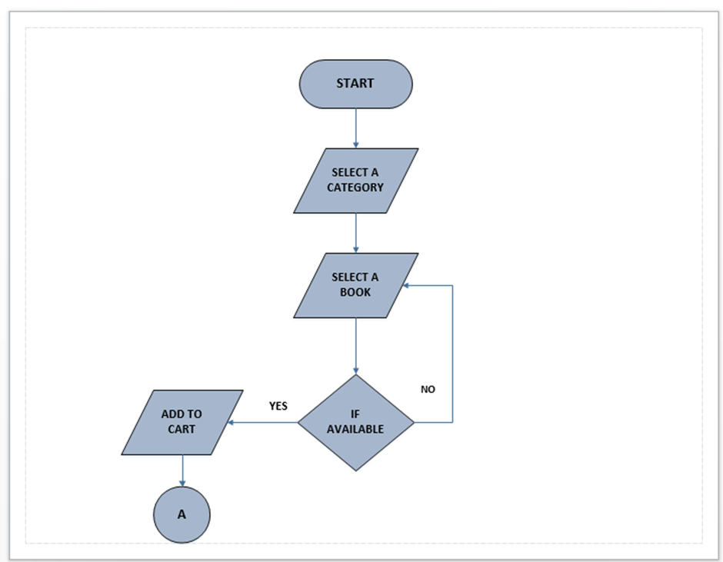

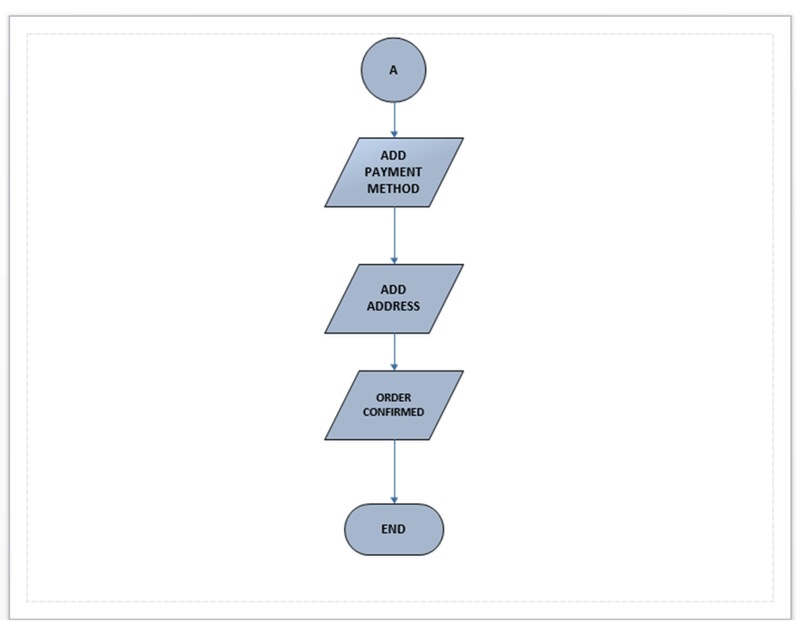

**Task No. 2: Taking Admission in university.**  
  
**Solution:**

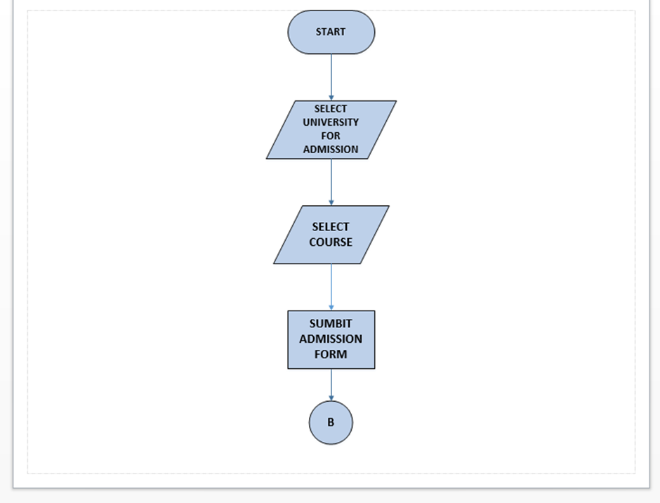

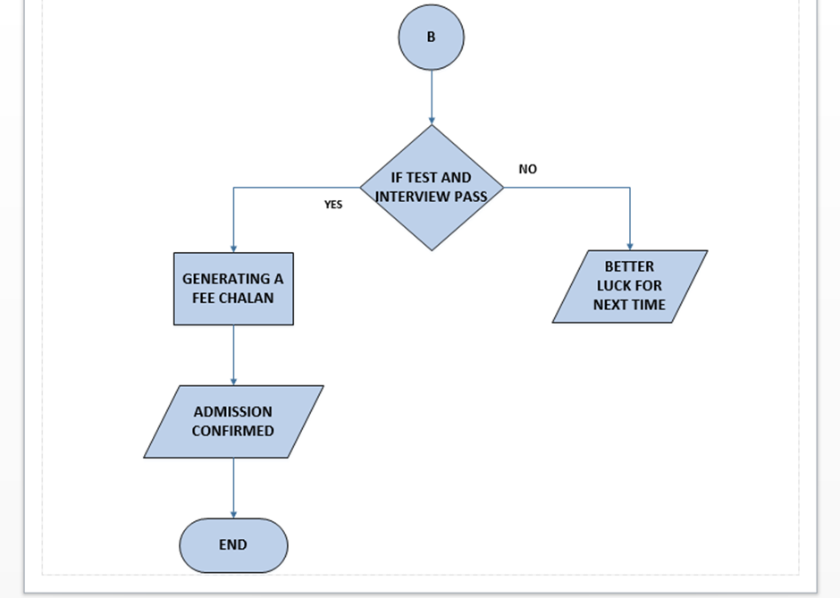

**Task No. 3: Fee payment procedure in a university.  
  
 Solution:  
  
 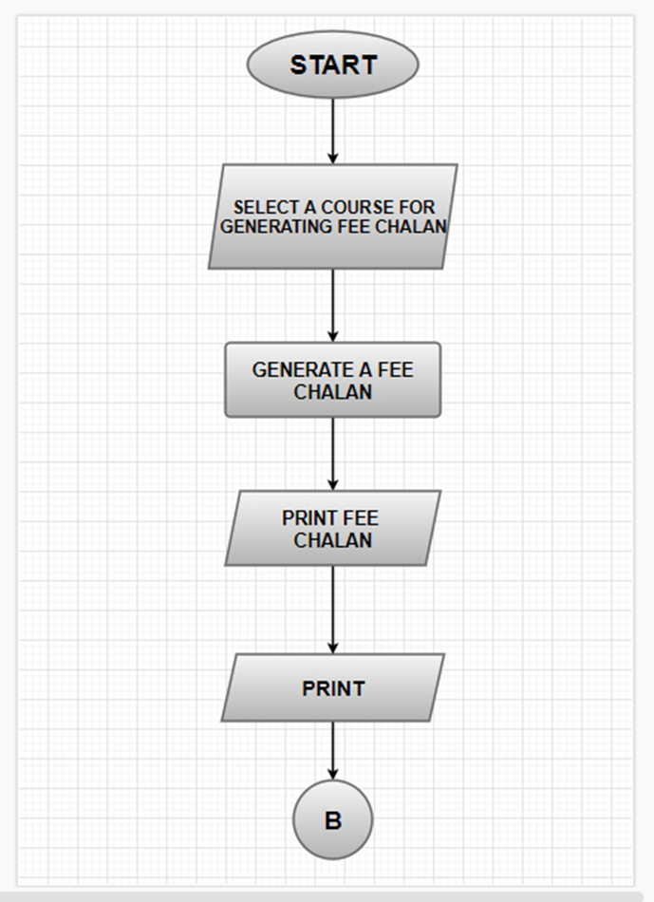  
  
  
  
  
  
  
  
  
  
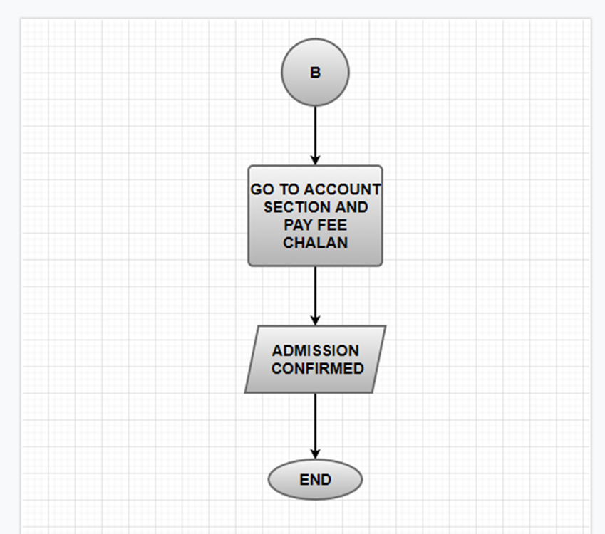**

**Task No. 4: Reporting a crime in police station  
  
 Solution:  
  
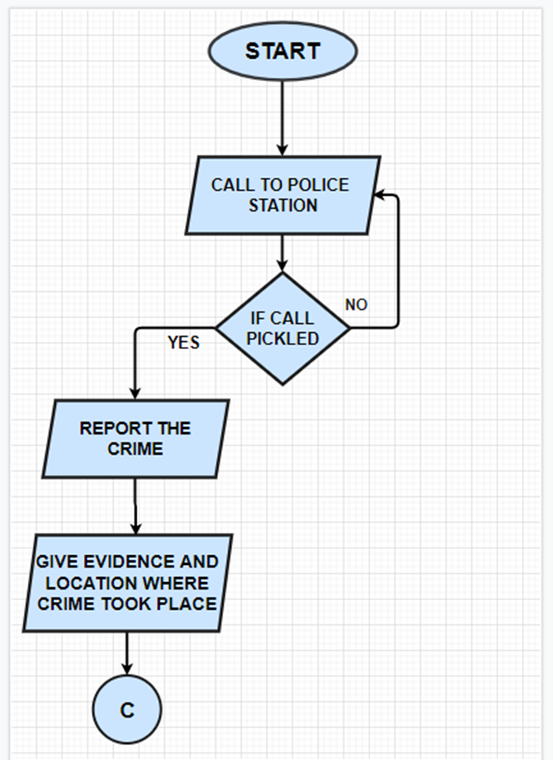**

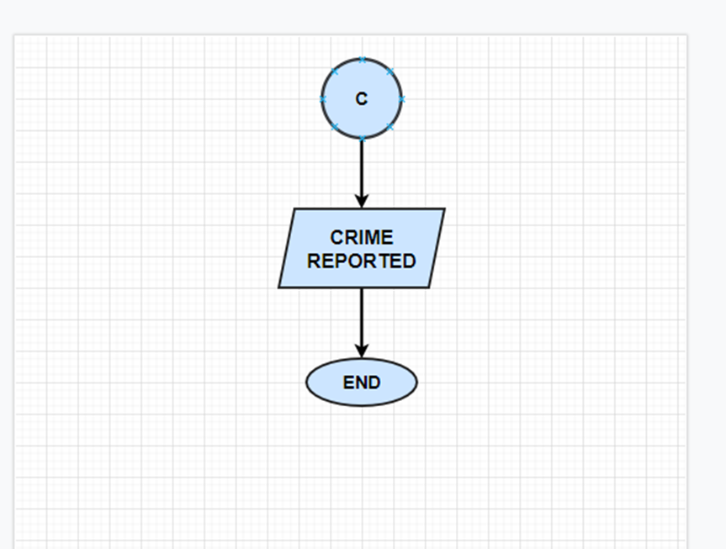

**Task No. 5: Hiring a cab.  
  
 Solution:  
  
  
 